MINI STUDENT MANAGEMENT APP

WEEK 1 TO WEEK 3 PRACTICAL PROJECT DOCUMENTATION
modecay sendwah
bit/2024/54918

1. INTRODUCTION
The Mini Student Management App is a mobile application developed using Flutter. The purpose of the system is to allow users to register students, store student information locally, and view saved student records through a simple and user-friendly interface.
The project was developed as part of practical learning activities focusing on Flutter development, user interface design, navigation, form handling, and local database storage.

2. PROJECT OBJECTIVES
The objectives of the project were:
- To develop a login system.
- To create a student registration module.
- To store student records locally.
- To display saved student information.
- To implement navigation between screens.
- To design a modern and responsive user interface.
- To test the application on an Android emulator.

3. SYSTEM REQUIREMENTS

Hardware Requirements
- Laptop/Desktop Computer
- Minimum 4GB RAM
- Android Emulator or Android Device

Software Requirements
- Flutter SDK
- Dart SDK
- Visual Studio Code
- Android Studio
- Android Emulator
- Android SDK
- Git

4. TOOLS AND TECHNOLOGIES USED
Tool | Purpose
Flutter | Application Development
Dart | Programming Language
VS Code | Code Editor
Android Studio | Emulator and SDK Management
SQLite | Local Database Storage
Git | Version Control

5. SYSTEM DESIGN
The application consists of the following screens:
- Login Screen
- Registration Screen
- Dashboard Screen
- Student Registration Screen
- Student Records Screen

Navigation Flow
Login → Dashboard → Student Registration → Student Records
6. SYSTEM DEVELOPMENT
The application was developed using Flutter widgets and navigation techniques.
Major components implemented include:
- TextFields
- Buttons
- Forms
- Navigation Routes
- SQLite Database
- Responsive Layouts

7. USER INTERFACE DESIGN
The user interface was designed to be simple, clean, and user-friendly.
Design considerations included:
- Proper spacing
- Readable typography
- Consistent color scheme
- Easy navigation
- Mobile responsiveness

Login Screen
The login screen allows users to enter username and password credentials.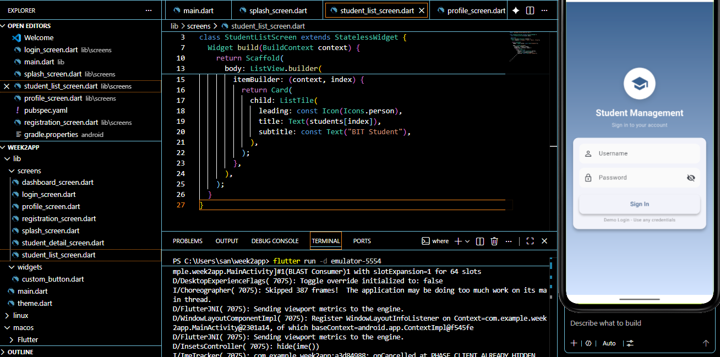

Registration Screen
The registration screen allows users to create a new account.


Dashboard Screen
The dashboard acts as the central navigation area of the application.
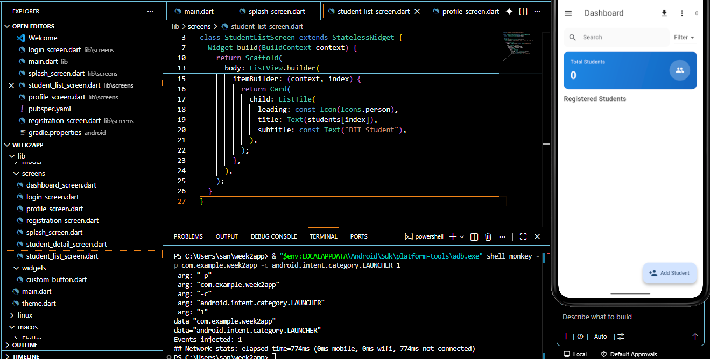

Student Registration Screen
This screen allows users to enter student information.
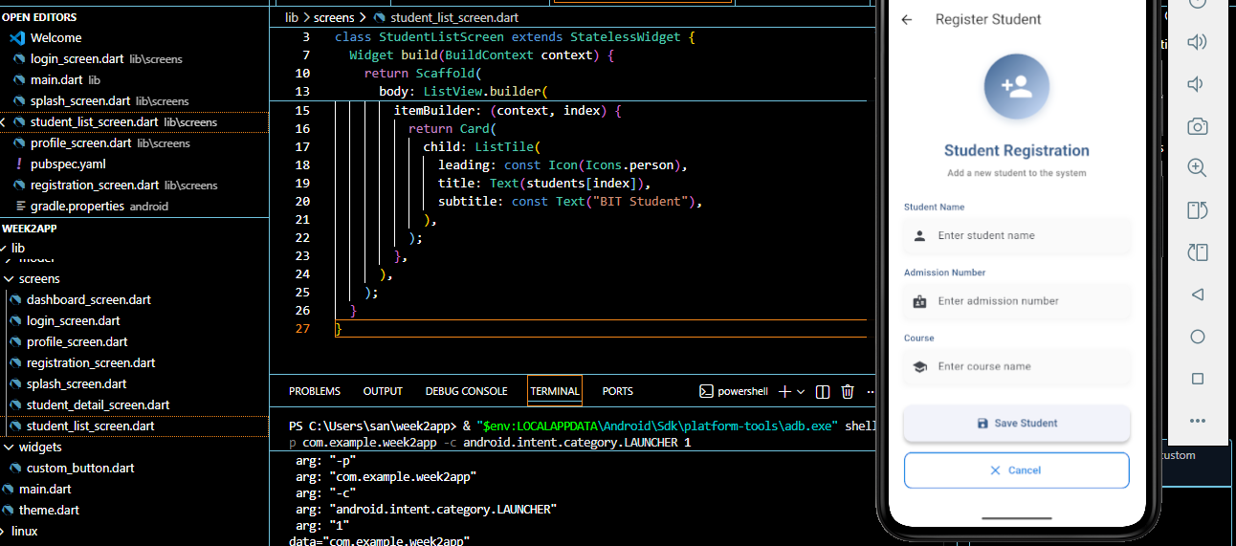

Student Records Screen
This screen displays all saved students.
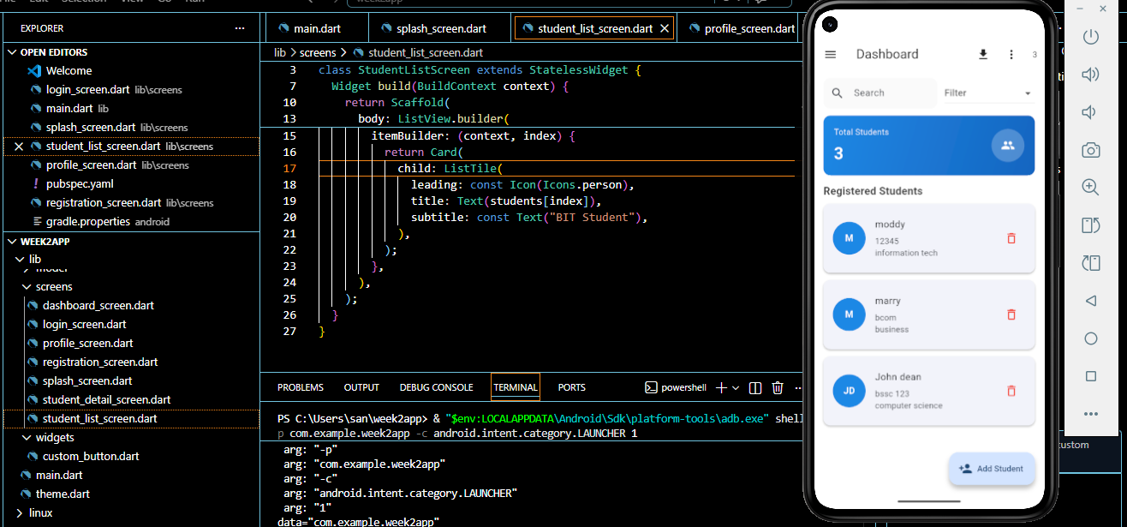

8. SYSTEM FEATURES
The implemented features include:

Login Module
- User login interface
- Input validation

Registration Module
- User registration form
- Data capture

Student Management Module
- Add student records
- View saved students
- Store data locally

Navigation Module
- Route-based navigation
- User-friendly transitions

9. DATABASE IMPLEMENTATION
SQLite was used as the local storage database.
Functions implemented:
- Insert Student
- Retrieve Students
- Display Student Records

10. TESTING AND RESULTS
The application was tested using the Android Emulator.
Testing activities included:
- Login testing
- Registration testing
- Student data entry testing
- Student records retrieval testing
- Navigation testing

